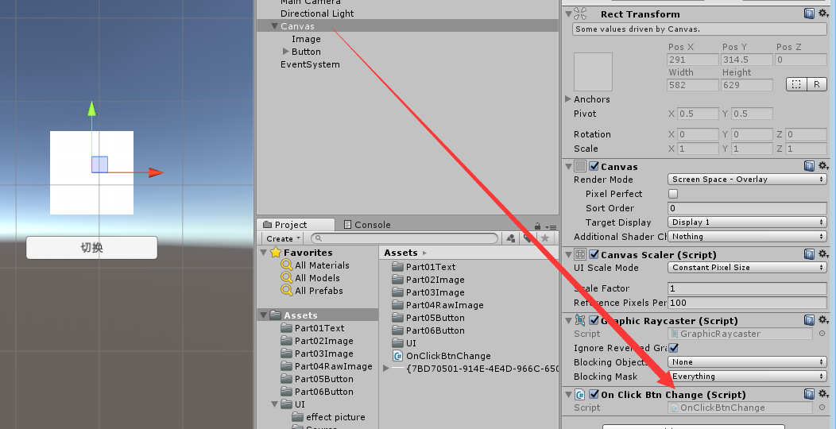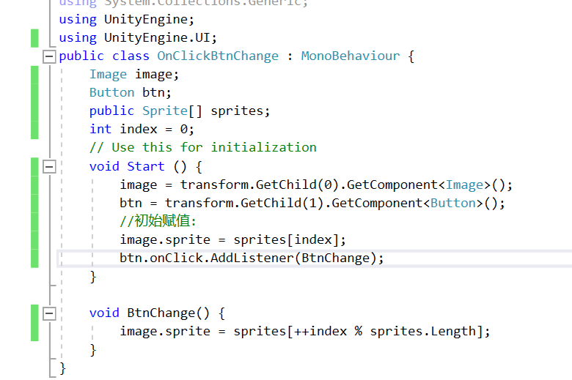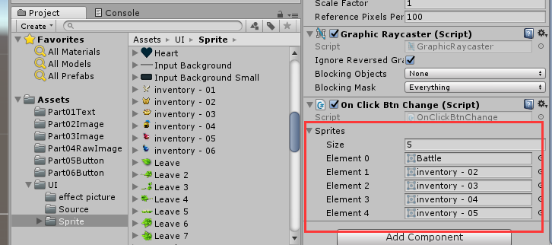

using UnityEngine.UI;

public class BtnChange : MonoBehaviour

{

Image image;

Button btn;

int index = 0;

public Sprite[] sprites;

void Start()

{

image = transform.GetChild(0).GetComponent<Image>();

btn = transform.GetChild(1).GetComponent<Button>();

//赋初值

image.sprite = sprites[index];

btn.onClick.AddListener(BtnChange1);

}

public void BtnChange1()

{

image.sprite = sprites[++index % sprites.Length];

}

}